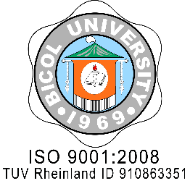
BICOL UNIVERSITY
ANNEX B: Application Letter
___________________________
(UNIT/COLLEGE )
Legazpi City
ISO 9001: 2015
SOCOTEC SCP000722Q

_______________
(Date)

The President
Bicol University
Legazpi City

(Through Channels)

Sir/Madam:

Greetings of Peace!

I have the honor to apply for a scholarship / extension under the Bicol University-Human Resource Development Program (BU-HRDP) to enable me to earn the Degree: _______________________________________________ at _________________________________
(School)

during the academic period from ________________________________ to ____________________with ________________________________________________________.
(type of benefits)

I promise that I will abide with all the policies rules and regulations attached thereto as provided for in the BU-HRDP Guidelines.

Thank you very much and more power.

Very truly yours,

_______________________

BU-F-HRMDO-81 Revision: 1
Effectivity: July 6, 2016

